# Homework: ASP.NET MVC Essentials

This document defines the homework assignments from the ["ASP.NET MVC" Course @ Software University](https://softuni.bg/courses/asp-net-mvc/). Please submit as homework a single zip / rar / 7z archive holding the solutions (source code) of all below described problems.

## Make empty controllers

Your task is to write empty controllers to serve as the application logic base.

You should have the following controllers:

* HomeController – Here you should write the home page actions
* AccountController – This is the default AccountController. It is not necessary to change it.
* TweetsController – Here you should write all actions related to the tweets
* UsersController – Here you should write profile and edit actions…
* NotificationsController – All things about notifications should be in this controller.

You can choose to leave the ready ManageController there or remove it.

## Create the application home page

Your task is to write a controller, actions and views for the home page.

The application home page should list all tweets by all users, chronologically. Make the action and view use paging. Display only 10 tweets on page. The page size cannot be changed.

Use **ViewModels** to display only necessary information about the tweet.

Every tweet should have favorite, retweet, report, reply and share buttons.

## Create the user home page

The user home page should display all tweets created by the followed users. Logged in users cannot access the application home page. When the user is logged in the home page should display only the tweets that are created by followed users.

Logged in users can post new tweet. Make form in the user home page for posting new tweet. Make the action for the posting new tweet in TweetsController.

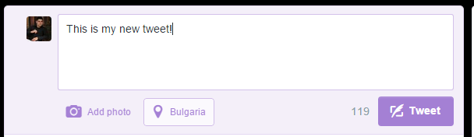

## Create the public user profile page

Each user should have a public profile page. A user profile should have his / her own tweets, users he / she is following, followers and favorite tweets.

You can see the twitter profile page for example.

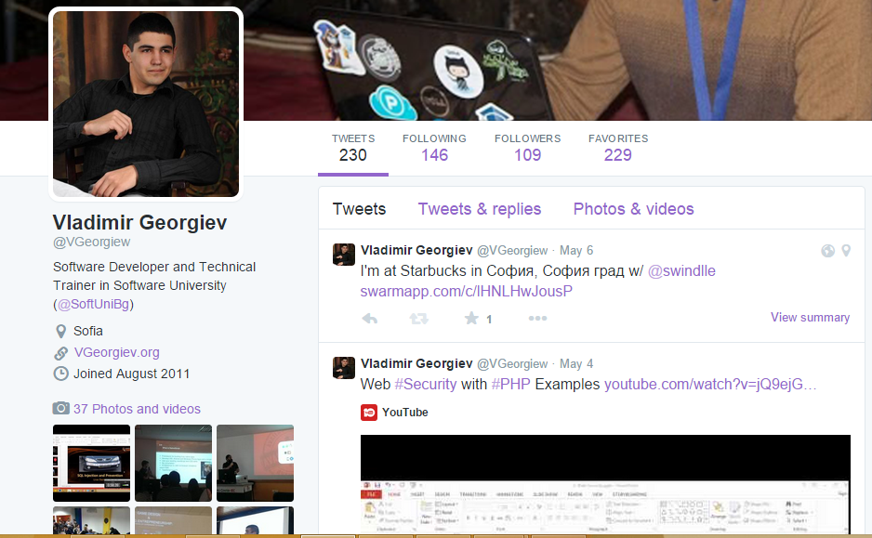

## Create a “Notifications” page

* Users receive notifications for retweet, favourite tweet and for new followers.
* A notification has content, date and user.

Make a controller for notifications and two actions for all notifications and a single notification. You should also create views for every action.

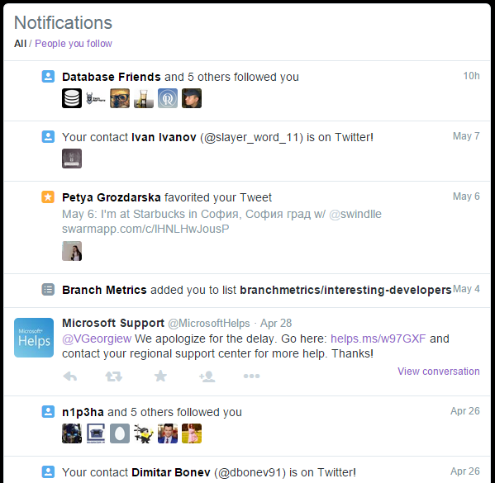

## Create the “Edit profile” page

Your task is to write the edit profile page. Every user can edit his / her own profile. You can use the built-in **ManageController** to help you with the business logic, or you can write your own controller.